KDooleyArt 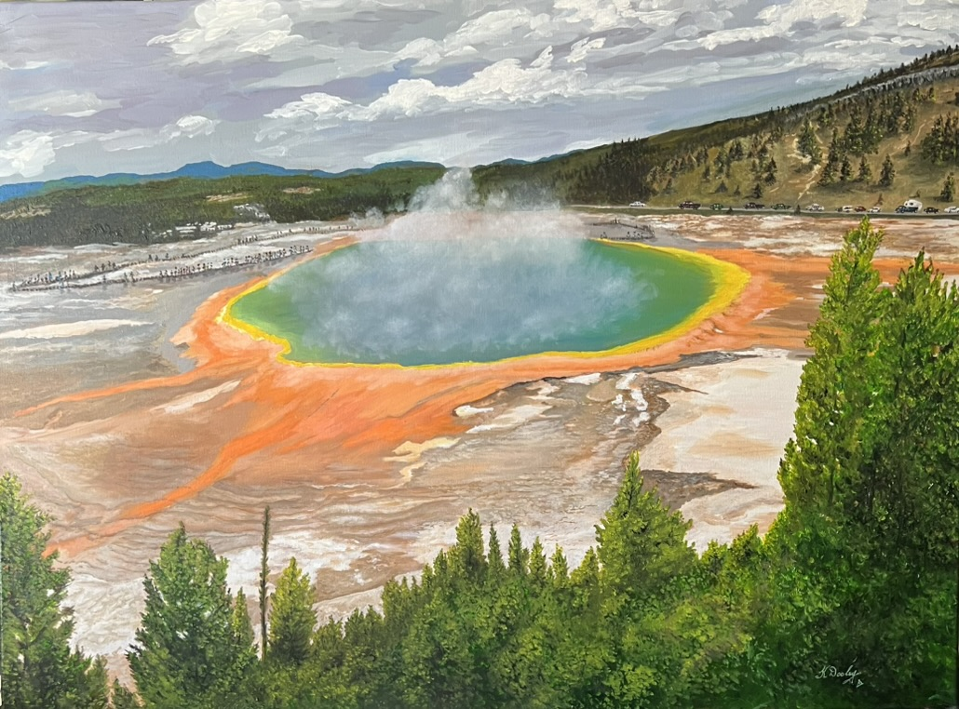
Kevin H. Dooley
Southwestern Oil & Mixed-Media Artist

PORTFOLIO

Artist Statement

My artwork is inspired by the landscapes, cultures, and spirit of the American Southwest. Working primarily in oil and mixed media, I seek to capture the character, color, and atmosphere that make this region unique. Whether depicting expansive desert vistas, historic architecture, persons, or the everyday beauty of Southwestern life, I strive to create work that reflects both a sense of place and a personal connection to the subject.

Texture, color, and composition play important roles in my creative process. I am drawn to the interplay of light and shadow across the landscape, as well as the rich visual history found throughout the Southwest. Through layers of paint and mixed-media elements, I aim to convey depth, movement, and emotional resonance.

While my work is rooted in realistic observation, it is also shaped by interpretation and memory. Each piece represents more than a specific location or scene; it is an expression of the feelings and impressions that remain long after the moment has passed.

My goal is to create artwork that invites viewers to pause, reflect, and experience a deeper appreciation for the beauty, history, and enduring spirit of the Southwest.

Artist Biography
My journey as an artist began in childhood, when I started drawing and painting before entering elementary school. My father, an accomplished artist who exhibited his work and received recognition in juried shows, was an important early influence and mentor. His encouragement helped foster my lifelong connection to creativity.
I explored a variety of mediums, including mixed media and watercolor, before discovering oil painting as a teenager. Oils quickly became my preferred medium because of their richness, versatility, and ability to capture light, texture, and atmosphere. Early influences included Vincent van Gogh and Impressionism, but over time my work evolved toward realism — a style that allowed me to more fully express my connection to the subjects I paint.
More than fifty years ago, I moved to Albuquerque, New Mexico, where I developed a deep appreciation for the landscapes, history, and cultures of the Southwest. Traveling throughout New Mexico and the surrounding states, I became inspired by the region’s vast deserts, dramatic skies, historic communities, and the enduring spirit of the people who call the West home.
Although I continued creating art throughout my adult life, my artistic pursuits competed with two demanding careers — first in criminal justice and later as a college educator in that field. After earning bachelor’s and master’s degrees, I eventually devoted myself fully to painting, allowing art to become the central focus and most rewarding adventure of my life.
I began exhibiting my work through one of New Mexico’s oldest co-op galleries and have completed commissions featuring Southwestern subjects. My work is held in private collections throughout the United States. The greatest compliment I receive is when viewers say they can feel my love of the West in my work. That connection continues to inspire me to create paintings that celebrate the beauty, character, and spirit of the Southwest.

Artwork
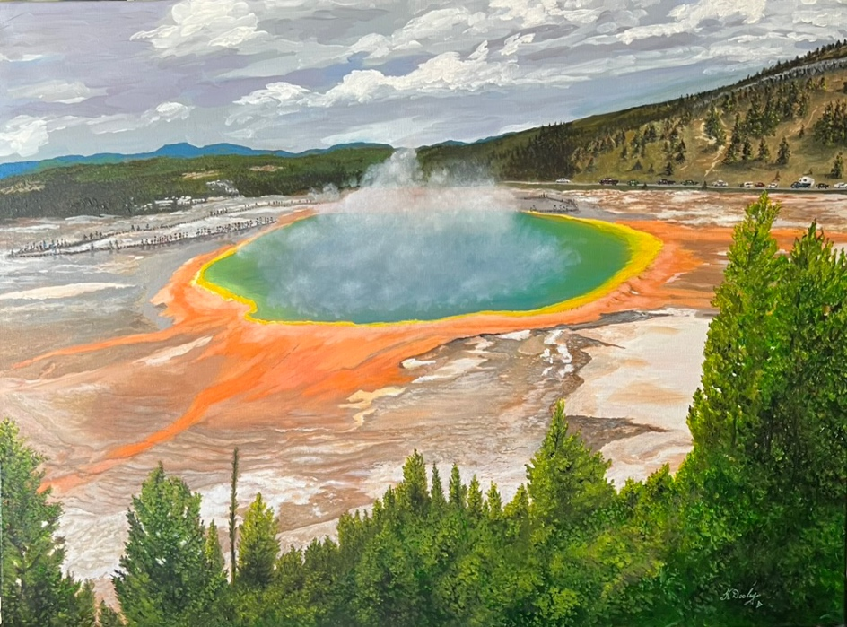
Rainbow Pool Yellowstone
30x40” Oil on Canvas 2026
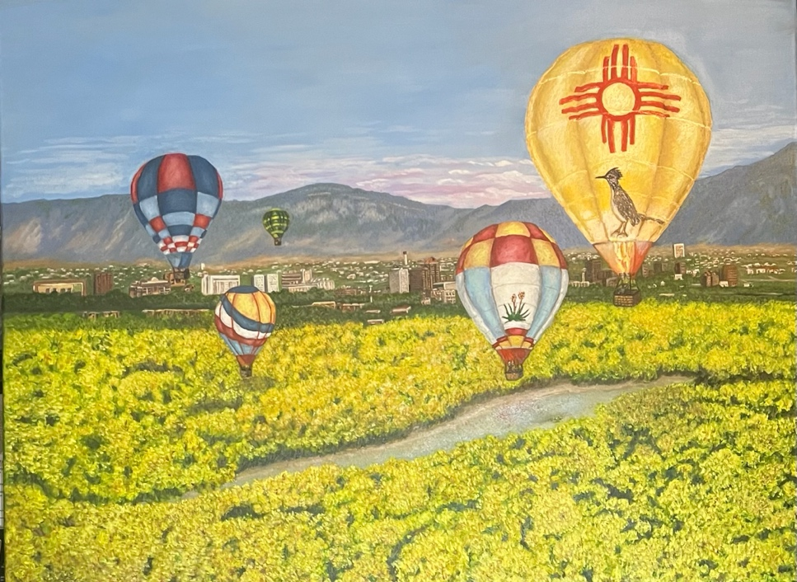
Balloons Over Albuquerque
30x40” Oil on Canvas 2026
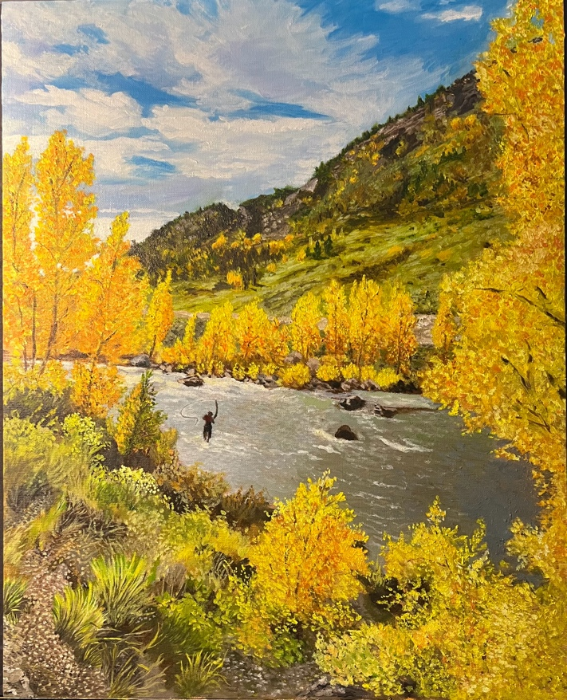
Fly Fishing in Durango
16x20” Oil on Canvas 2026
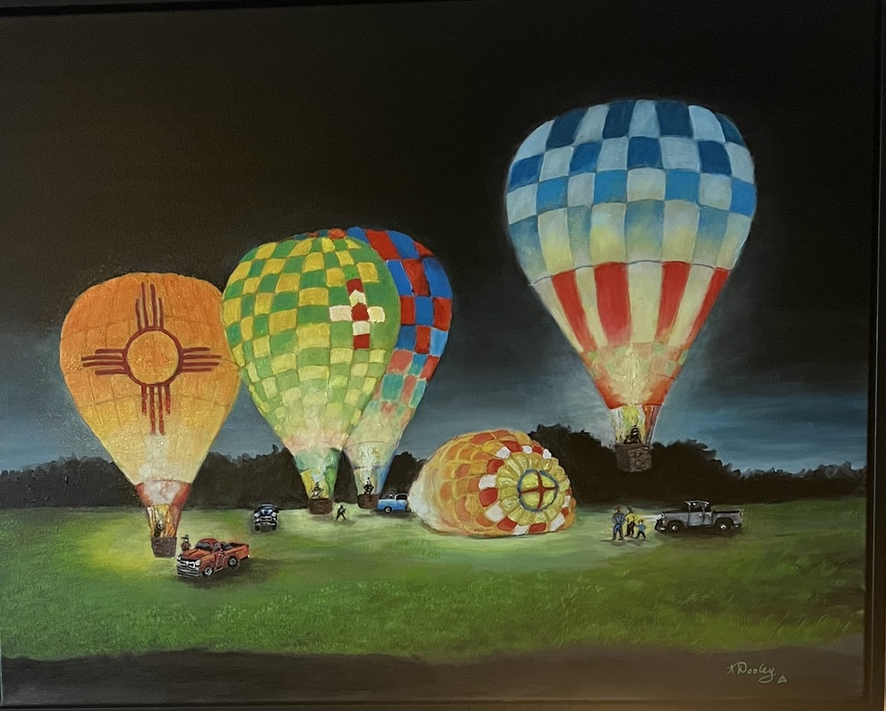
Go Glo New Mexico
16x20” Oil on Canvas 2023
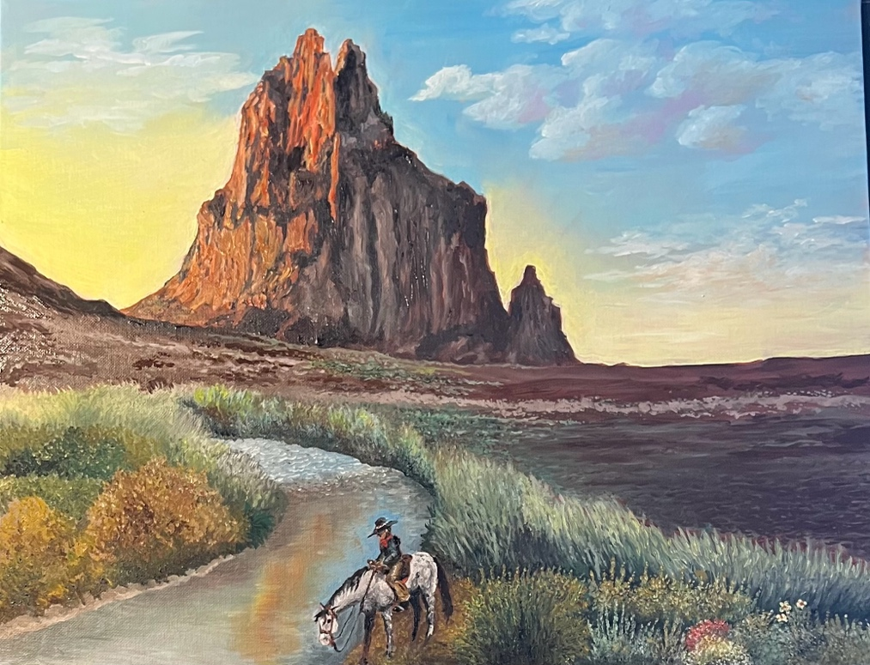
Taking a Break at Shiprock
16x20” Oil on Canvas 2023
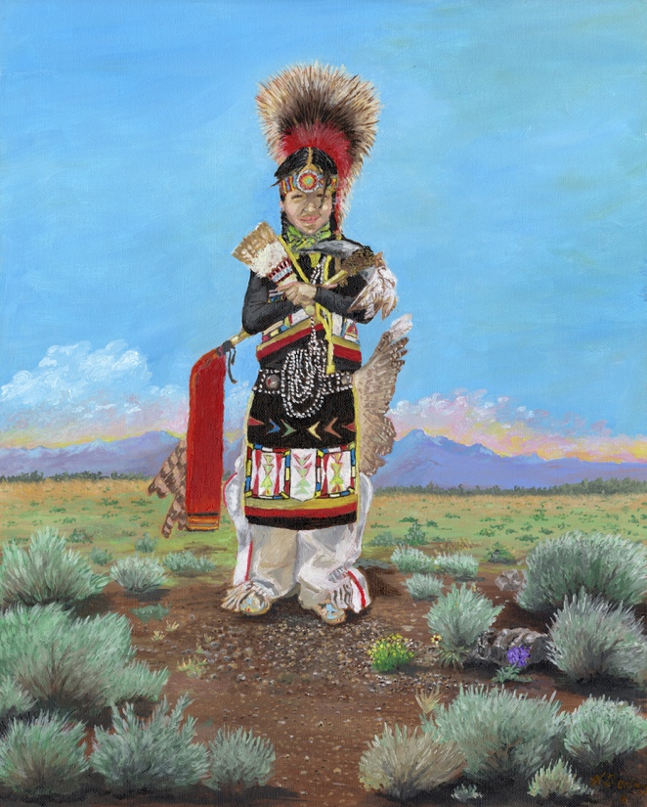
Youthful Traditions
16x20” Oil on Canvas 2023
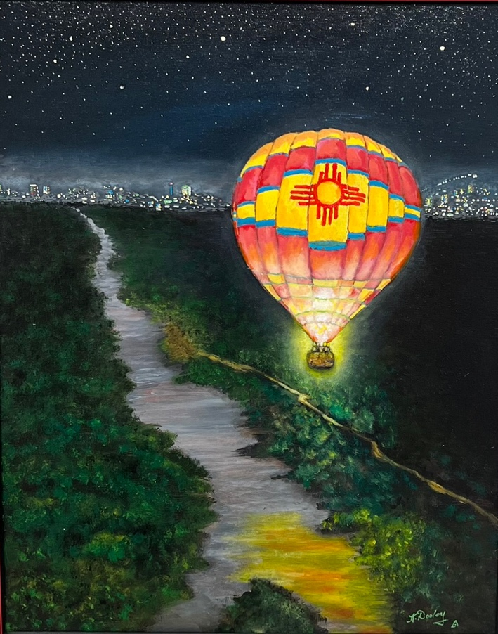
Night Flight over the Rio Grande
16x20” Oil on Canvas. 2025

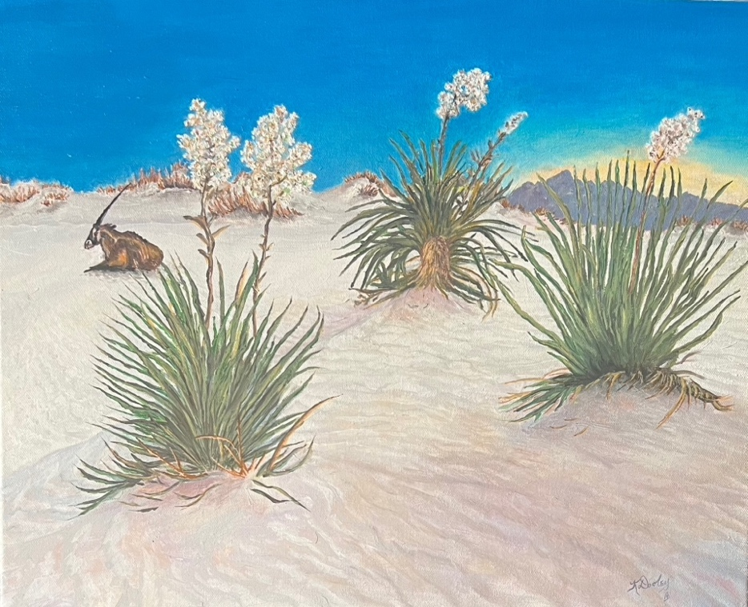
Taking a Break in White Sands NM
16x20” Oil on Canvas 2023
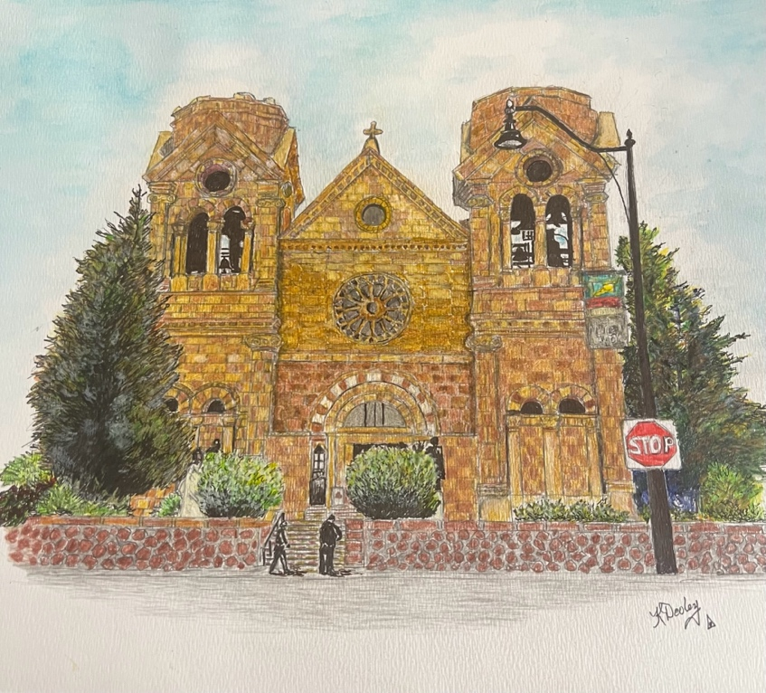
St. Francis Cathedral in Santa Fe, NM
11x14” Mixed Media 2025

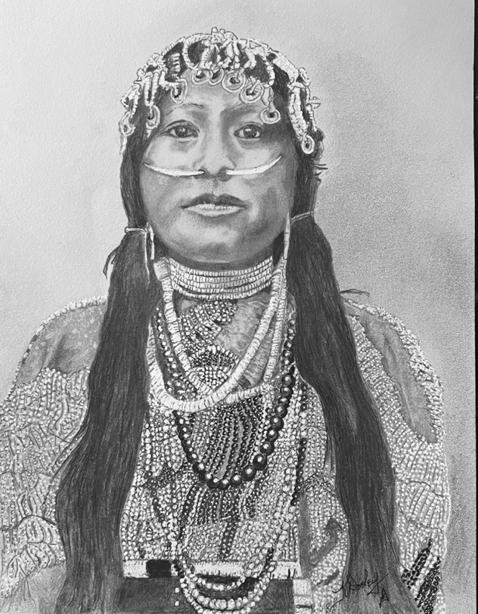
Wisham Woman
11x14” Mixed Media 2025

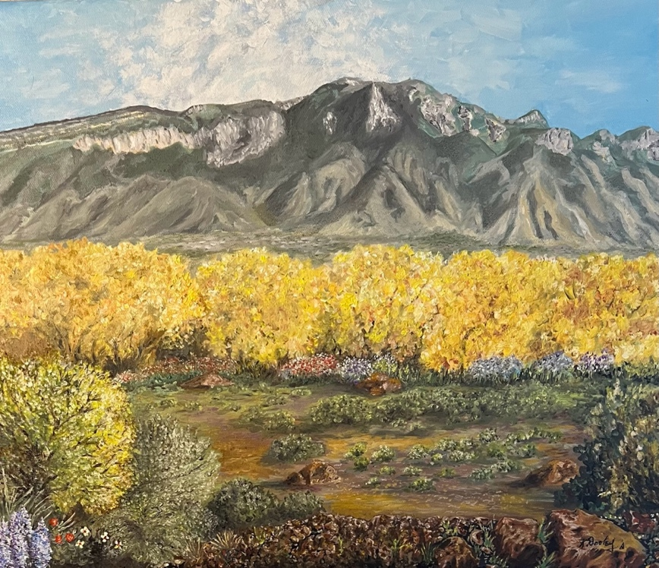
Watermelon Mountain in Albuquerque
16x20” Oil on Canvas 2023

Exhibitions/Awards/Gallery Representation

I am an active member of:
- Rio Grande Art Association (RGAA) which includes Masterworks exhibits.
- Albuquerque Art Business Association (AABA)
- This year I joined the Corrales Society of Artists (CSA) and will exhibit my work as a part of their Corrales Art Studio Tour in the future.
- I have been a member of the Yucca Art Gallery in Old Town Albuquerque, which is a known center for art galleries in New Mexico. I have exhibited my work there for the past three years and was featured artist during one month of this year.
- I have also exhibited some of my work at a local business in Albuquerque and in the Albuquerque International Airport.

My works have been juried into the Rio Grande Art Association’s annual Art show and contest for the past two years.

Contact Information:
KdooleyArt
Kevin H. Dooley
Phone: (505) 463-8085

Website:
http://Kdooley.Art

